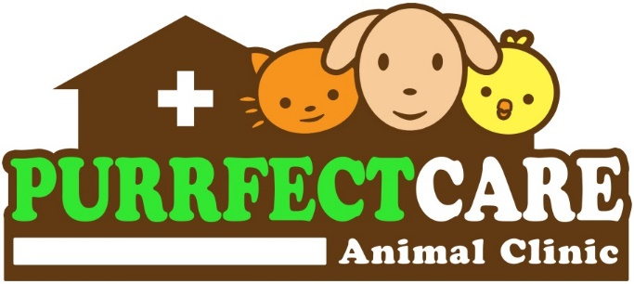
Barrientos Street, Layawan, Oroquieta City
(Near St. Therese Hospital)
Contact no: 0926-740-8552

CONSENT FOR EUTHANASIA

Date: ______________________

Owner’s Name: __________________________________________________
Address : __________________________________________________
Pet’s Name: _____________________________________
Color: ____________________ Sex: __________________
Species: __________________ Breed: ________________

I, the undersigned, do hereby certify that I am the owner or duly authorized representative of the owner of the animal described above. I hereby give Dr. Johanna Benissa A. Butalid (Veterinarian) and her employees or representatives full and complete authority to end the life of the said animal and to dispose of it in whatever manner they deem appropriate.

I acknowledge that Dr. Johanna Benissa A. Butalid has met with me personally and discussed the euthanasia of my animal. I also certify that, to the best of my knowledge, the said animal has not bitten any person or animal during the last fifteen (15) days and has not been exposed to rabies. I further understand that I assume financial responsibility for all services rendered.

By signing this form, I give permission to end this animal’s life and affirm that I have the authority to execute this consent.

_____________________________________________
Owner’s signature over printed name

Barrientos Street, Layawan, Oroquieta City
(Near St. Therese Hospital)
Contact no: 0926-740-8552

CONSENT FOR EUTHANASIA

Date: ______________________

Owner’s Name: __________________________________________________
Address : __________________________________________________
Pet’s Name: _____________________________________
Color: ____________________ Sex: __________________
Species: __________________ Breed: ________________

I, the undersigned, do hereby certify that I am the owner or duly authorized representative of the owner of the animal described above. I hereby give Dr. Johanna Benissa A. Butalid (Veterinarian) and her employees or representatives full and complete authority to end the life of the said animal and to dispose of it in whatever manner they deem appropriate.

I acknowledge that Dr. Johanna Benissa A. Butalid has met with me personally and discussed the euthanasia of my animal. I also certify that, to the best of my knowledge, the said animal has not bitten any person or animal during the last fifteen (15) days and has not been exposed to rabies. I further understand that I assume financial responsibility for all services rendered.

By signing this form, I give permission to end this animal’s life and affirm that I have the authority to execute this consent.

_____________________________________________
Owner’s signature over printed name

